TR-610 Setup / Documentation
Sam Morstein
10/27/22

Introduction
The TR-610 dashboard is made of 3 different components: the Python script, the Oracle Database, and the APEX site. This will go through each aspect including set up and troubleshooting/maintenance.
Site Link: https://apexpw10.bmwgroup.net/ords/r/ws_apex_bs_planning_data/tr-610-monitoring/home

Python

Software Installation
The script was developed with Anaconda running Python 3.8.5. This was originally on WUSS, but it has been removed. There still might be a way to request the software through BMW. If not, the version that I built the script with is version 2020.11, which can be found at https://repo.anaconda.com/archive/ . “Anaconda3-2020.11-Windows-x86.exe” and “Anaconda3-2020.11-Windows-x86_64.exe” I think would both work. I’m not sure if there is a license required and if you could get one.
In case Anaconda cannot be obtained, Python can be downloaded from WUSS or from the internet with no IDE. On WUSS, only older versions of Python are available:
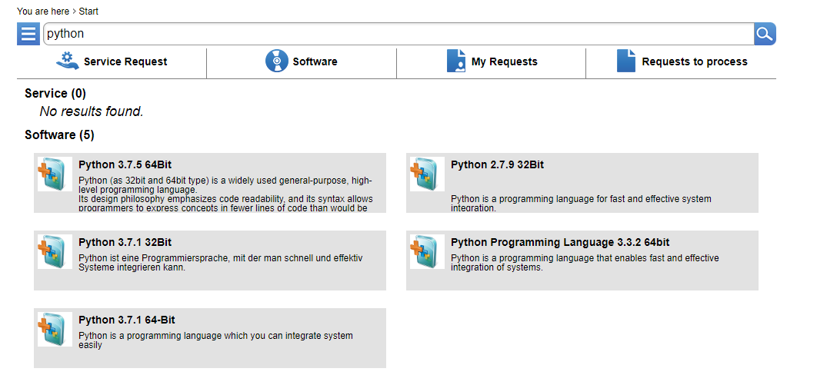
Python 3.7.5 might work but I am not 100% sure of that. Certain libraries that are required may not work properly with the code. Python 3.8.5 can be downloaded from the internet at https://www.python.org/downloads/release/python-385/ . An IDE of your choice can be downloaded which should work to allow you to easily run the script.

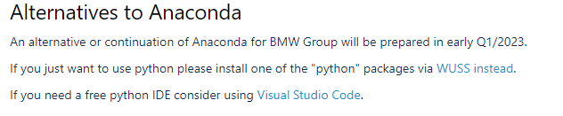

Script Setup
The script requires an empty folder to unzip files into and “TR_610_File_Locations.xlsx” which contains the file paths for the different directories where the tr610 csv’s are stored.
With a version of Python installed, the script should be able to be opened and viewed. You should see something like this. 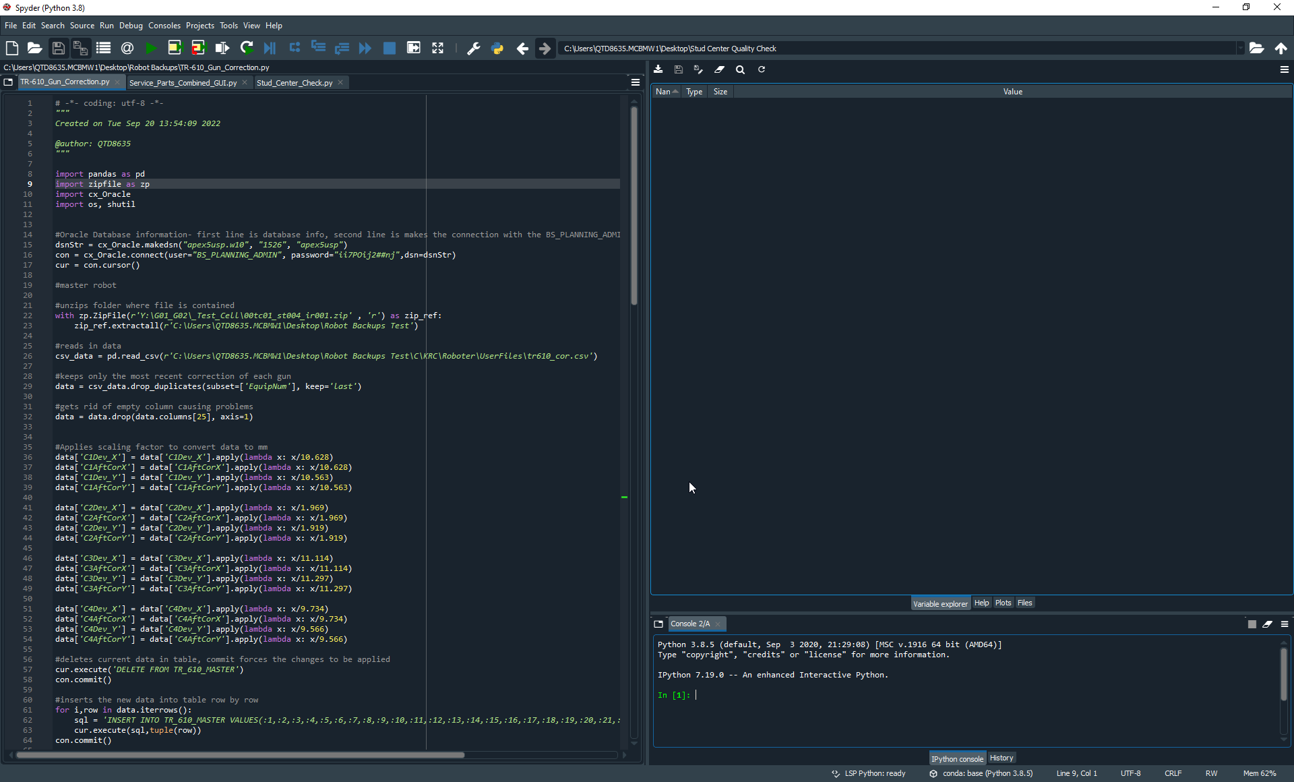
The script will not be able to run without erroring for 2 reasons: it requires additional libraries that are not installed and file paths are not properly configured. First, we will fix the all of the file paths in the script, which will help with the library installation.

Files paths on lines 22, 23, 26, 68, 72, 103, and 106 will potentially need to be changed.
The file paths in ”TR_610_File_Locations.xlsx” may need to be fixed as well.
Line:
22. This line reads in the tr610 csv for the master robot. The drive letter I used was “Y” but if the drive is mapped to a different letter on your machine, then this line will need to be changed.
23. This is the empty folder where files are unzipped to. The file path will need to be changed to the directory of your folder. Note the r’C: \....’, as this prevents the backslashes from causing problems.
26. This is the file path to where the unzipped tr610_cor.csv is located. Everything from C\KRC should be standard between devices but the file path before that needs to be changed.
68. This is the file path for the spreadsheet containing all the file paths of the zipped folders. This will need to be changed to where the spreadsheet is located on your computer.
72. This is the empty folder where files are unzipped to. The file path will need to be changed to the directory of your folder. Note the r’C: \....’, as this prevents the backslashes from causing problems.
103. This is the empty folder where files are unzipped to. The file path will need to be changed to the directory of your folder. Note the r’C: \....’, as this prevents the backslashes from causing problems.
106. This is the file path to where the unzipped tr610_cor.csv is located. Everything from C\KRC should be standard between devices but the file path before that needs to be changed.

File Locations Spreadsheet: Each line has the zipped folder’s file paths. The drive letter I used was “Y” but if the drive is mapped to a different letter on your machine, then every line will need to be changed. Otherwise, this is fine.

Once all the file paths are updated, the additional libraries can be installed. The libraries that will be needed can be seen at the top of the script:
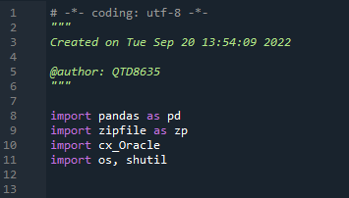
Now depending on if Anaconda was able to be installed or not will play a role in what libraries are needed. Certain libraries are also a part of Python’s standard library and should be preinstalled. At the minimum, I believe zipfile and cx_oracle will need to be installed. Luckily, regardless of which libraries are already installed, it is the same process for all libraries.
To install a library, type “pip install ______ --proxy=http://proxy.muc:8080” in the console
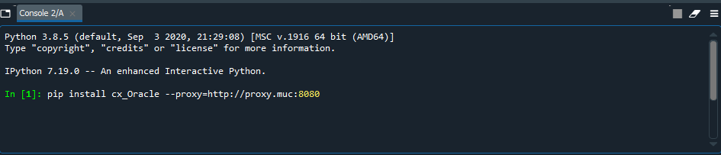
If the installation errors, “--user” being added to the end of the line may help. The installation may also error if the library is already installed. The console will let you know of the issue and recommend what you should do.
Once all the libraries that are directly imported are installed, try running the program. It still might error if an additional library is called by the other libraries that is missing. If this occurs, follow the same procedure for the missing library.

Running the script
Once the script will run without erroring, file paths should start appearing in the console.
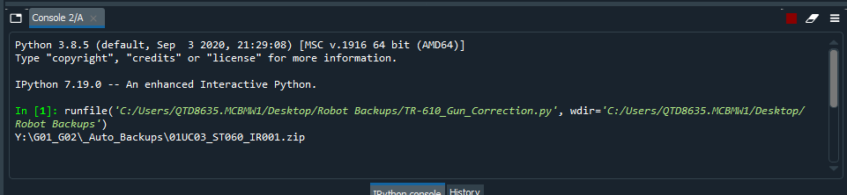
Occasionally a message will appear saying “Failed to read….”. This is perfectly normal and only means that there was no tr610 csv in the specific folder.
The script does not require any user input.
How the script works
The script itself is well commented on explaining the logic within it. Below is a flowchart which explains what the script is trying to accomplish on a higher level. For this to properly work, the script needs to be run nightly/ automatically at some interval. This will be explained in the next section.

Getting the script to run automatically
The recommended approach to getting a Python script to run automatically is to use Window’s Task Scheduler. The following link provides instructions on how to get it set up:
https://www.geeksforgeeks.org/schedule-a-python-script-to-run-daily/
On my machine, I was unable to set this up as I lacked admin permissions. This is the error it gets every morning:
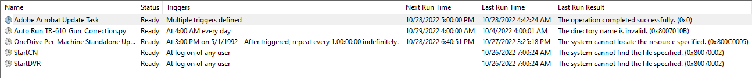
Additional settings may be needed for the script to run such as running regardless of the user being logged in or not:
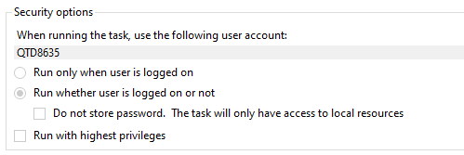

Oracle Database

Software Installation
If for whatever reason the tables in the Oracle Database need to be edited, SQL Developer can be downloaded from WUSS.
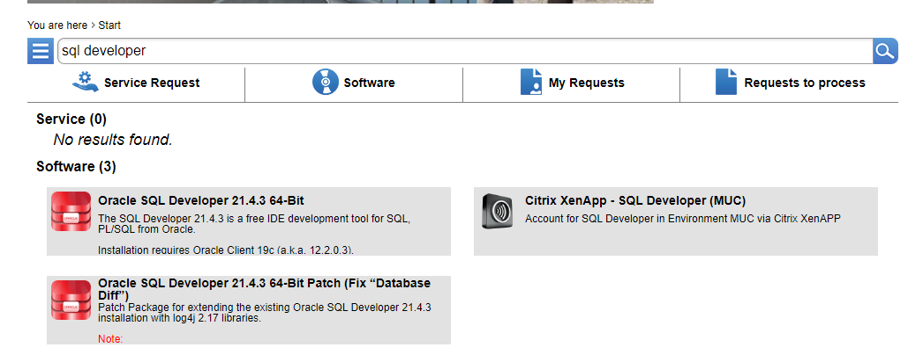
The tables are on the production database. Connection information for it can be seen below:
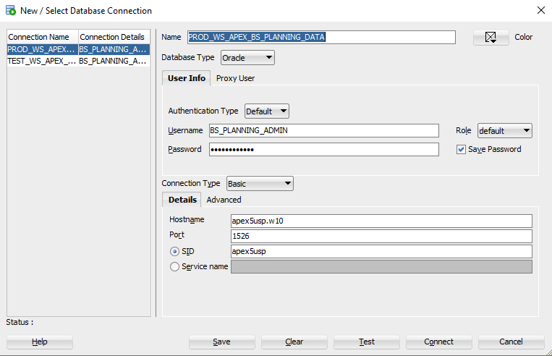
Reach out to Ryan Wentworth, TX-211 for the password for the database.

Tables
The only things on the database related to the TR-610 reporting are three tables.
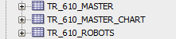
TR_610_MASTER_CHART is a table that exclusively holds the current correction info to display a chart on the APEX site. TR_610_MASTER is the table that holds the information from the master corrections file. TR_610_ROBOTS is the table that holds the individual robot correction info.
These tables should not require any upkeep or maintenance as the data is removed and readded by the Python script. However, if the data in the TR-610 csv’s change, then the table may need to have columns modified.

APEX Site

Access
Unlike the previous parts, there is no software download or installation needed to access the APEX site backend. It is all done on a website so all that is needed is access. The APEX development site can be found at https://apexpw10.bmwgroup.net/ords/f?p=4550:1:12739044426414
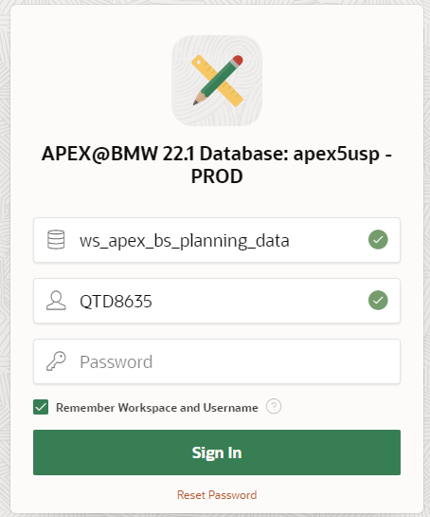
To get access, reach out to Megan Stanforth, TX202 or Ryan Wentworth, TX211 and they should be able to get you added as an allowed user.
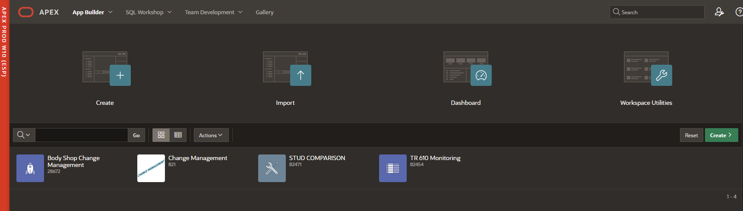
Once you have access to the APEX site, the TR610 website can be found by clicking on the app “TR 610 Monitoring” as shown above.

Site Overview
Essentially, there are only 2 pages that are needed to be worried about. The APEX site contains many default admin pages that would not need to ever be changed. Pages 1 and 2, however, have the content that potentially may want to be changed.
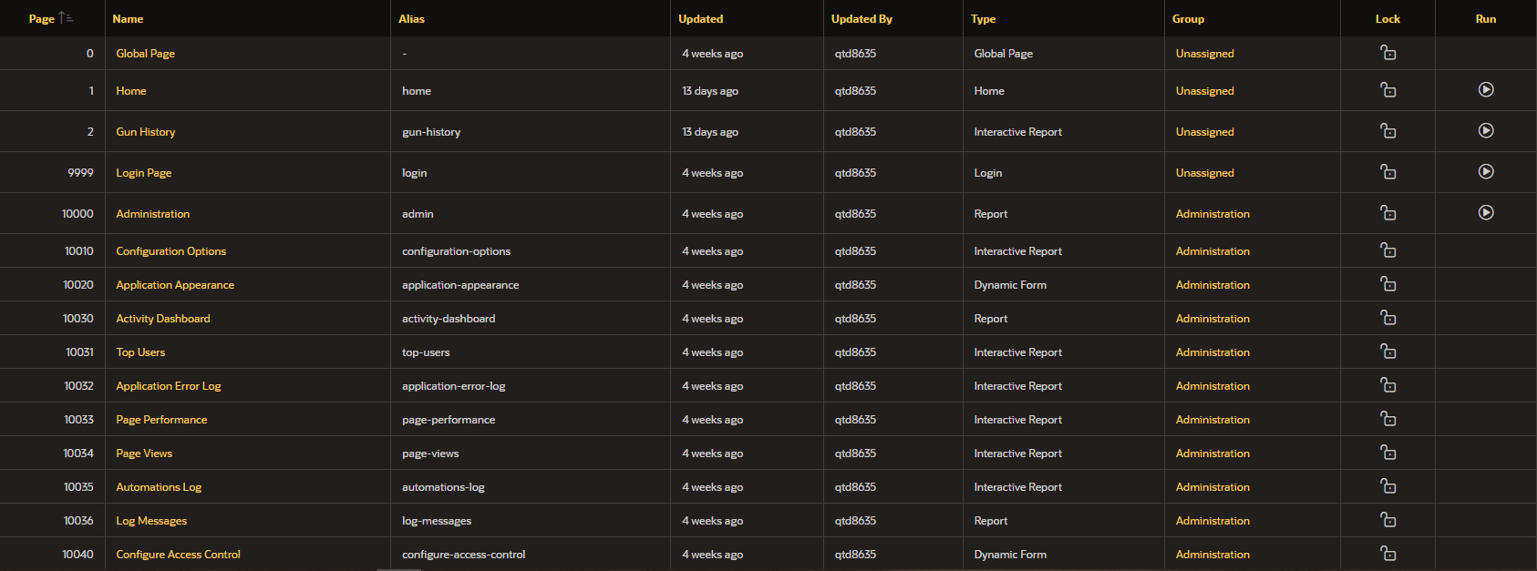
Page 1 Home:
This is the main page of the site, and it is where all the charts are displayed. It also has an area to choose the stud gun to view the before vs after of the gun correction. Overall, there would not be too much on this page that would ever need to be updated.
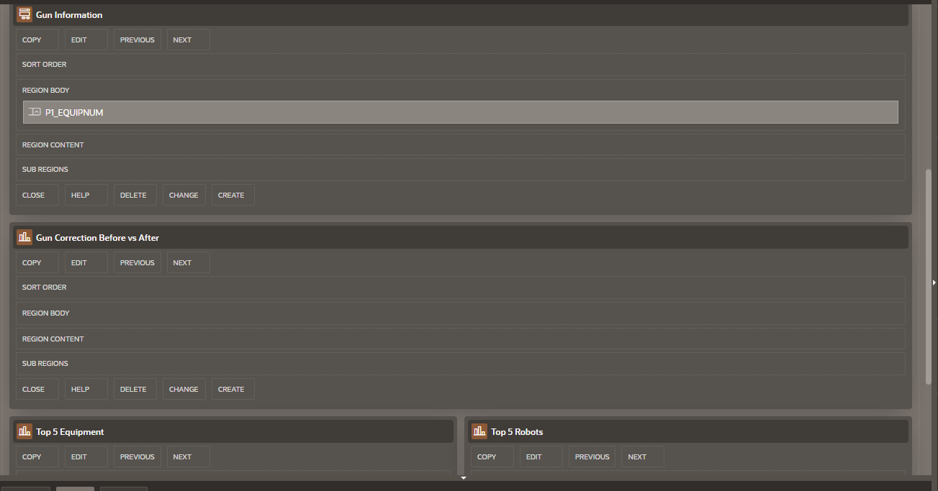
Page 2 Gun History:
This page is more text based as opposed to page 1, which is more chart based. This page will show the change history of the stud gun or robot if required. On this page, information about a gun’s most recent correction can also be viewed in more detail compared to the chart. Again, there should not need to be too much that would need to be changed on this page.
